**IBM-ADIT COURSE 2019-21**

**NSTI BHUBANESWAR**

**CORE MODULE 2 PROJECT ASSIGNMENT**

**Team Members**

**1. Shubham Kumar**

**2. Sunik Nayak**

**3. Prahlad Kumar**

**4. Sagarika Khatua**

* **OBJECTIVE**

Assigned to Shubham Kumar and Team.

Set up a client server system architecture using windows server such that it has the following features:

a) Create a domain controller named "SKAT.COM"

b) Configure the DHCP and DNS where dhcp range will be of 97 IP addresses

c) Create 28 user accounts, 4 Groups and 6 OUs

d) Set 3 GPOs to be applied over 6 OUs

e) Each GPO should have the following policies:

1. First GPO should have enabled "Access data sources across domains", "Allow active scripting"

2. Second GPO should have enabled "Allow META REFRESH", "Display mixed content"

3. Third GPO should have enabled "Allow file downloads", "Java permissions"

* **Lists of hardware/ software Requirements: -**
* Oracle Virtual Box Software.
* 4 GB RAM, 100 GB HARD DRIVE
* Windows Server 2012.

**Aim 1: Creating a domain controller named “SKAT.COM”.**

**Step 1**

First of all, login to your Windows Server 2012 and open the Server Manager. In the Server Manager click on "Add Roles and Features".

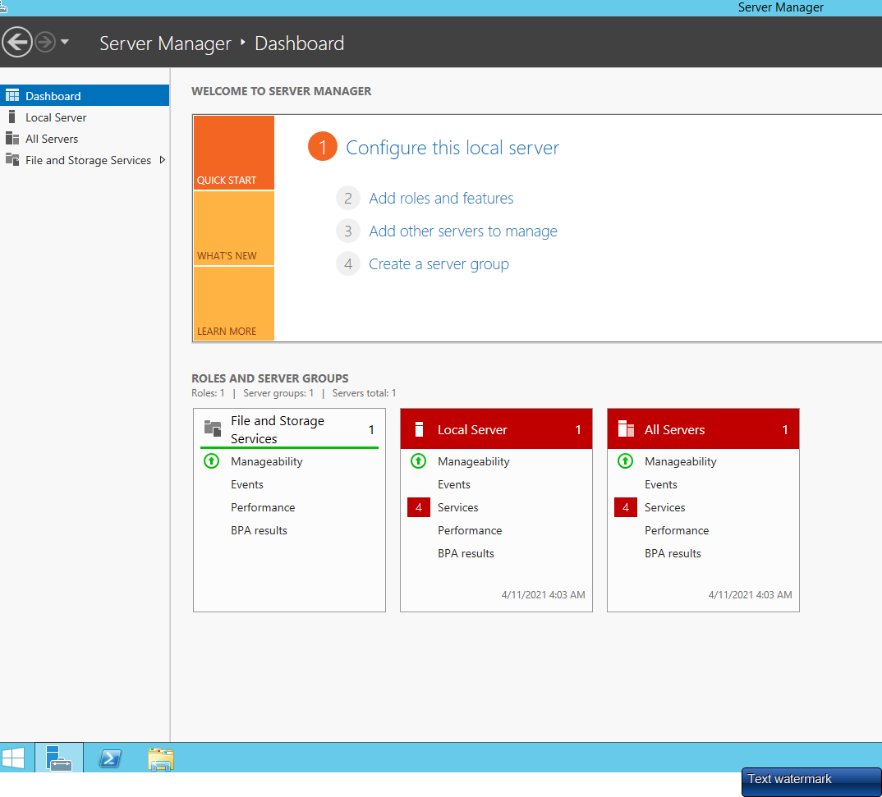

**Step 2**

Now some important information will be given, you can read it and then click on the "Next" button.

After clicking on Next, The Installation type page will be opened that will ask you to select one of the options. Select the first option i.e., "Role Based on Feature based Installation" and then click on "Next".

**Step 3**

Now you must select a Server from the Server Pool. Since I have only one server, my default server is automatically selected. After selecting the server click on "Next".

Now a list will be displayed in front of you from which you must select "Active Directory Domain Services".

**Step 4**

Now there will be certain features to be selected. You can select any of them or can just click on "Next" if you simply want to move on.

**Step 5**

Now you must provide permission to the Server to get restarted if required.

**Step 6**

After the installation completes, don’t **close it**, instead click on "Promote this Server to Domain Controller".

This will take you to the Configuration Wizard. In the Configuration Wizard select the first option i.e. "Add a New Forest" and provide the Root Name (I provided skat.com) then click on "Next".

**Step 7**

After that the Domain Controller option page will be opened in which you need to select the Forest Functional Level and Domain Functional Level. You can select these from a list of available options. Here I had selected Windows Server 2012 in both of them. You must also provide the password so that in case a problem occurs you can recover from it.

**Step 8**

On the Next page an automatic NetBios name will be provided, you do not need to provide any new name, just click on the "Next" button.

Now various paths for various files will be provided, here also just click on "Next".

**Step 9**

Now you will reach the Installation page, here click on the "Install" button to begin the installation.

After the installation is completed, your server will restart on its own and it will take a long time to restart so just wait for the procedure.

**Aim 2: Configure the DHCP and DNS where DHCP range will be of 150 IP Addresses**

* **Configuring Forward lookup Zone in DNS Server: -**

1. Open server manager dashboard, and then open tools. Scroll to DNS and click it.

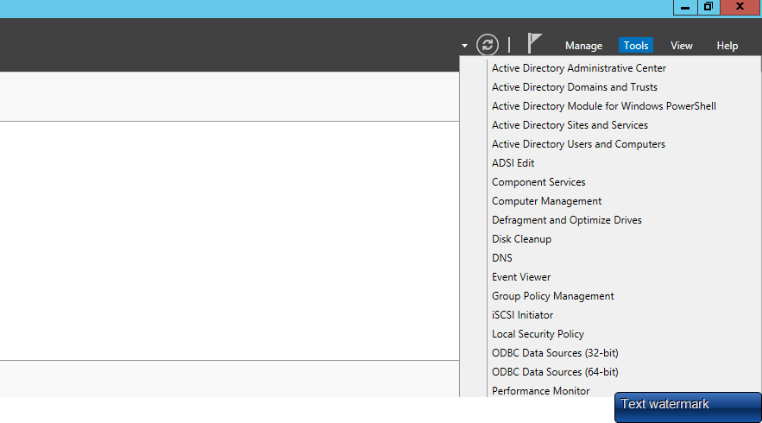

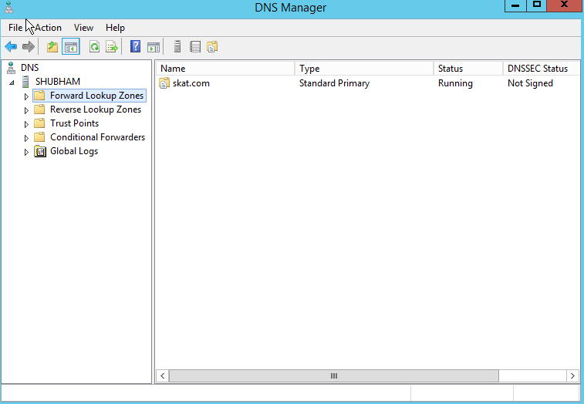

1. Right-click **Forward Lookup Zones** and click **New Zone**
2. Click **Next**
3. Provide the zone name and click **Next**

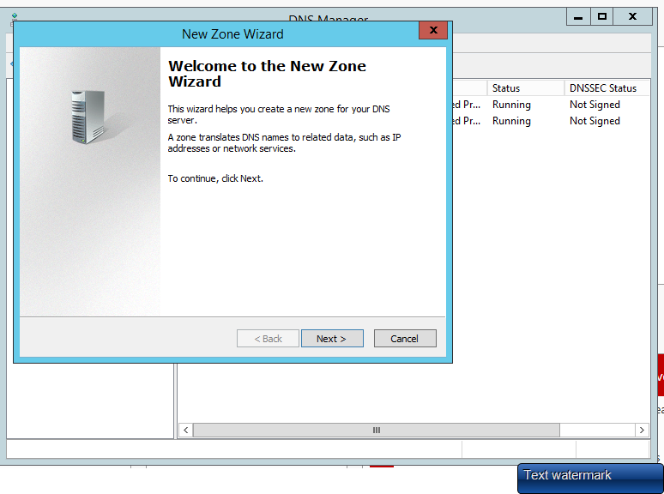

1. Choose **Create a new file with this file name** and click **Next**

Choose **Do not allow dynamic updates** and click **Next**

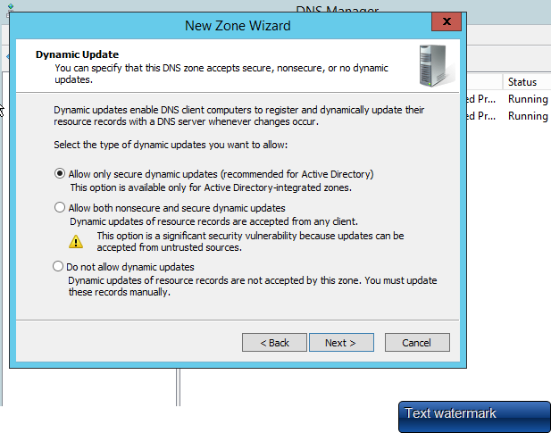

Click **Finish** to successfully create the new zone

* **Configuring Reverse lookup Zone in DNS Server: -**

1. Open server manager from task bar and click on Tools. Scroll to DNS and then click on it



1. Right-click Reverse Lookup Zones and then click New Zone
2. Click **Next**
3. Choose **Primary zone** and click **Next**
4. Choose **IPv4 Reverse Lookup Zone** and click **Next**

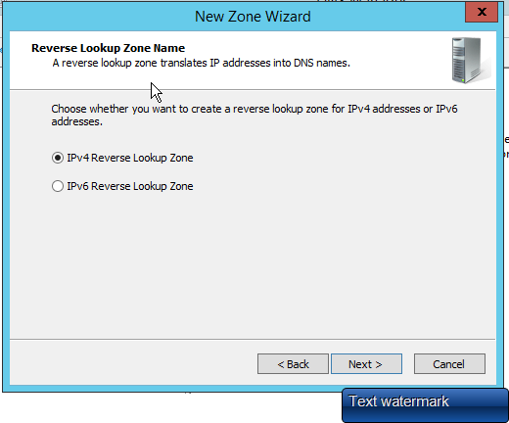

1. Provide **network ID** and click **Next**

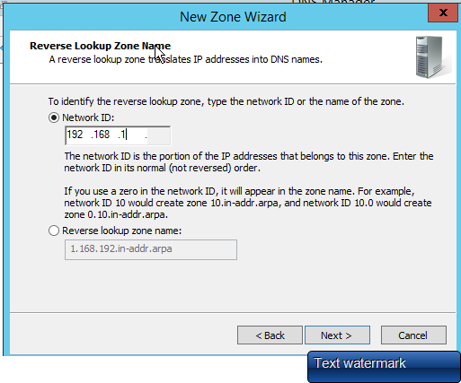

1. Choose **Create a new file with this file name:** and click **Next**
2. Choose Do not allow dynamic updates and click Next



1. Click **Finish** to end the wizard

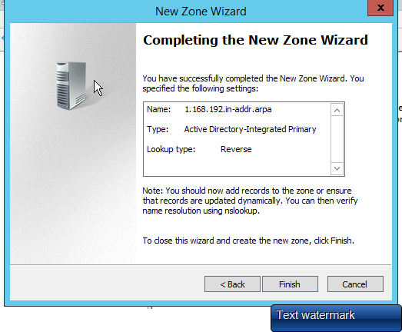

* **Configuring DHCP Server and Creating Scope**

1. Open Server Manager and click **notifications icon.** A small window will appear. Click **Complete DHCP configuration.**

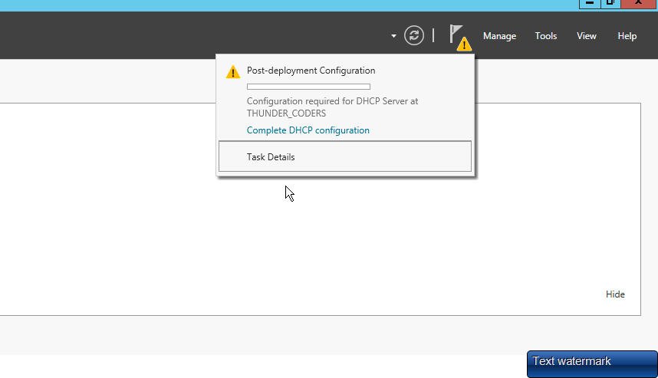

1. Click **Next**

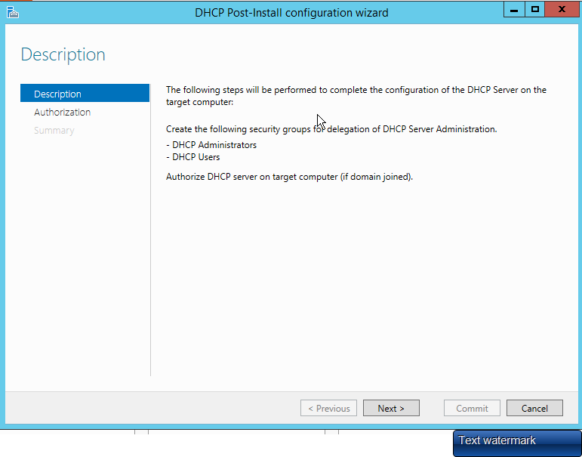

1. Choose Skip AD authorization since we do not have any AD configured and click **Commit**
2. Read the summary and click **Close**

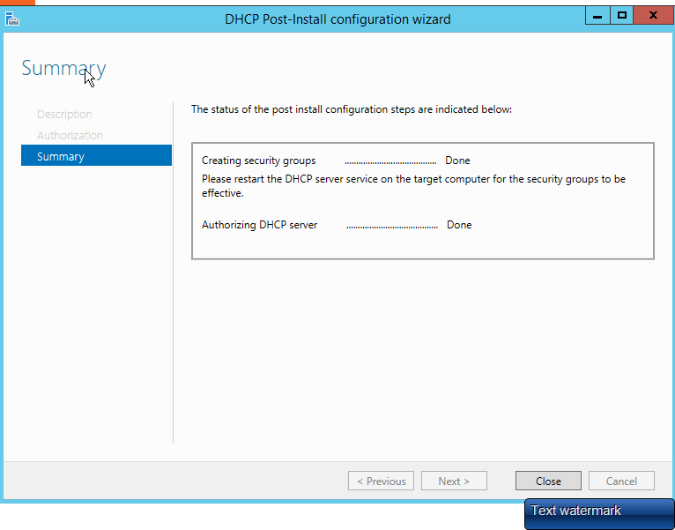

1. Open Server Manager and click on **Tools.** When a small window appears, scroll to **DHCP** and click it

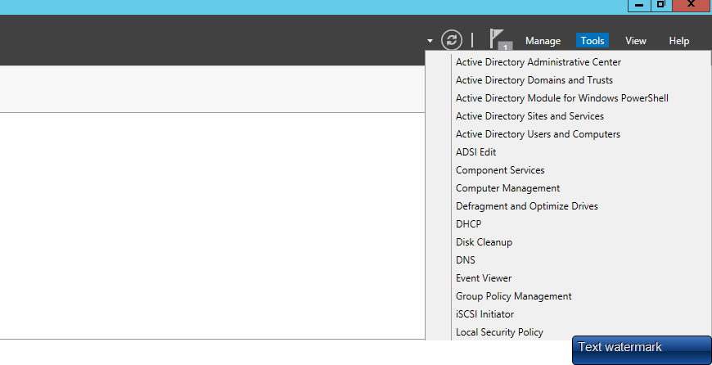

1. In management console, right click on **IPv4** and scroll to **New Scope** and click it.

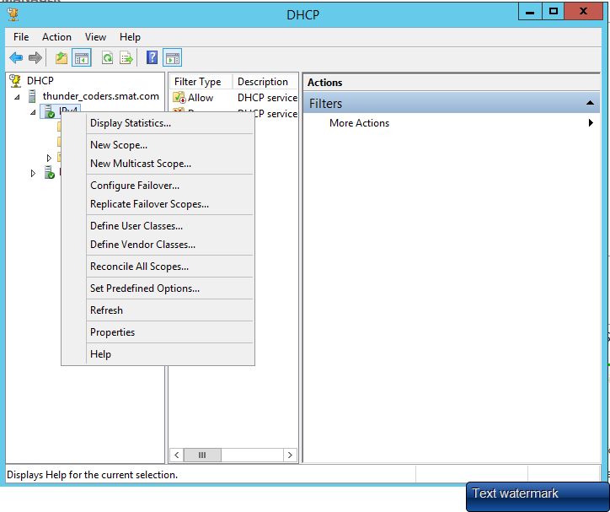

1. Click **Next**

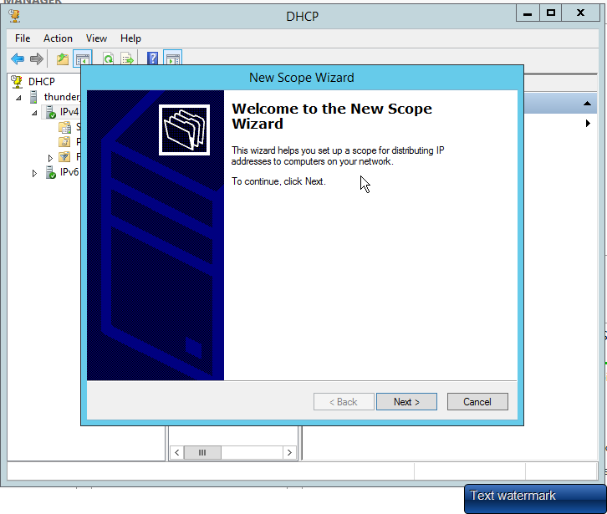

1. Provide name and meaningful description of this new scope (I give SKAT.COM) and click **Next**

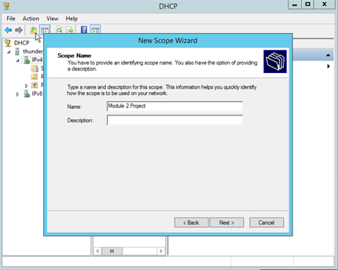

1. Provide IP address range 97(192.168.0.1 to 192.168.0.97) along with sub net you need to distribute to client machines and click **Next**
2. Provide any IP addresses to exclude from pool and click **Add**. I have excluded a first IP address which is statically assigned to my DHCP server. Click **Next**
3. Keep lease duration as 8 days and click **Next**

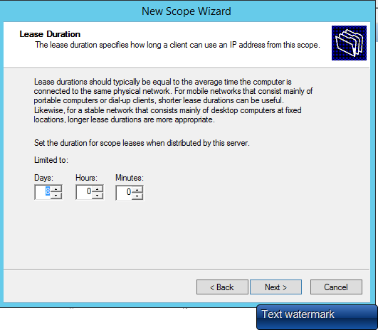

1. Choose **No, I will configure these options later** and click **Next.**
2. Click **Finish** to end the new scope wizard

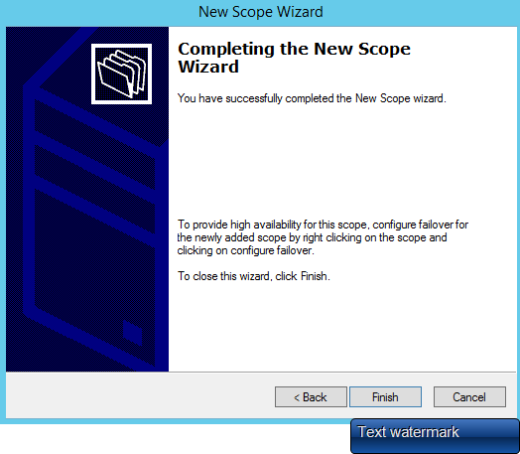

1. Right-click on new scope you just created in above step and click **Activate**

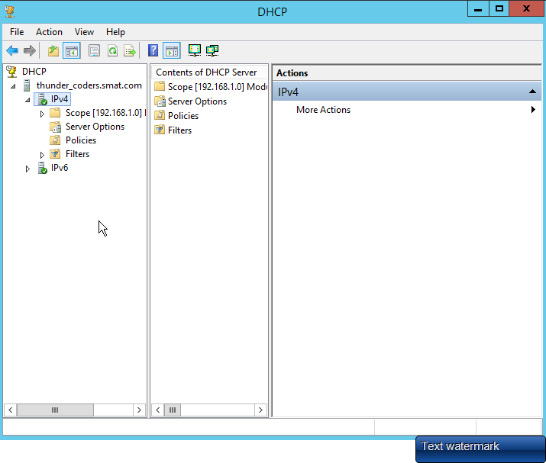

1. Right-click on your server, scroll to **All Tasks** and then click **Restart** to finish with configuration
2. **Open Command Prompt and Type: ipconfig /all**

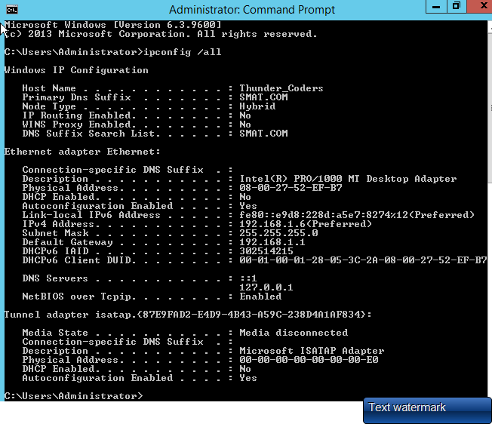

**Aim 3: Create 28 User Accounts, 4 Groups and 6 OUs.**

Step 1: Add User Accounts in Active Directory

* Run [Server Manager] and click [Tools] - [Active Directory Users and Computers].

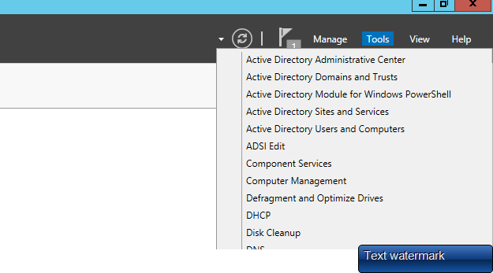

* Click with right button [Users] on left tree and select [New] - [User].

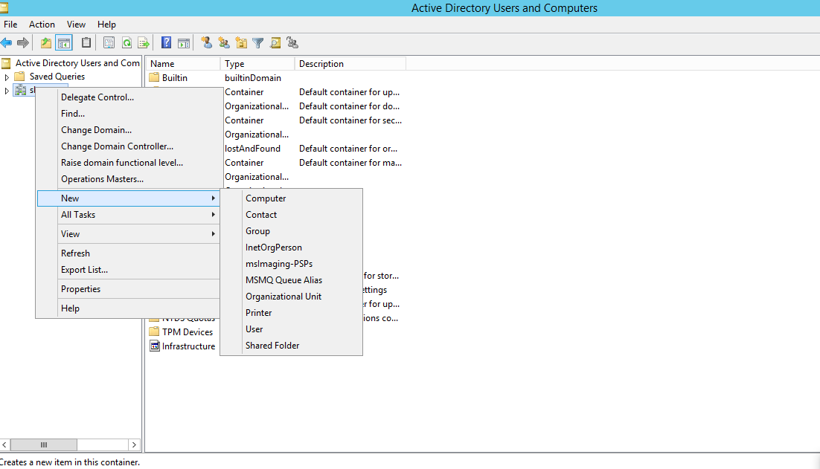

* Input User name or Logon name for new user and password

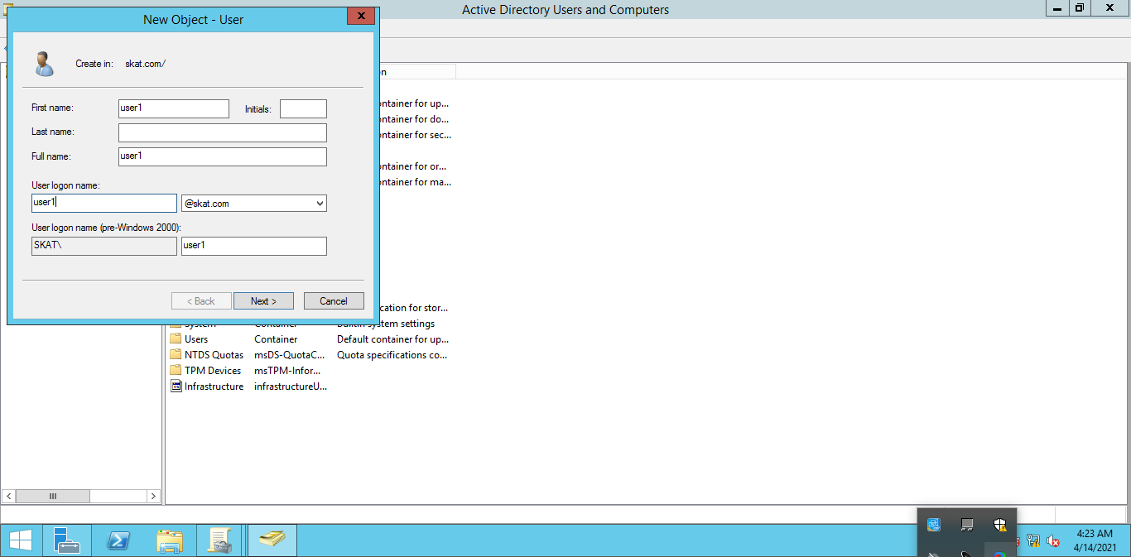

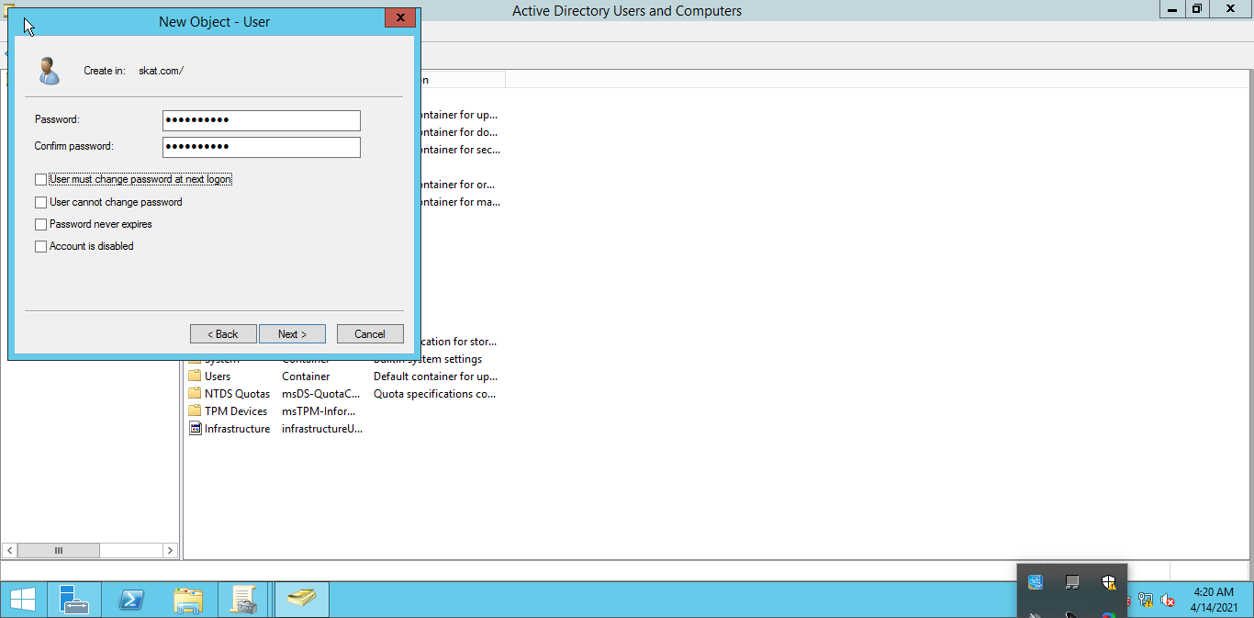

* Check contents you set and click [Finish] button.
* 25 new users added.

**Step 2: Creating a 4 Groups in Active Directory Users and Computer’s.**

1. Run [Server Manager] and click [Tools] - [Active Directory Users and Computers].



1. Click with right button [Group] on left tree and select [New] - [Group].

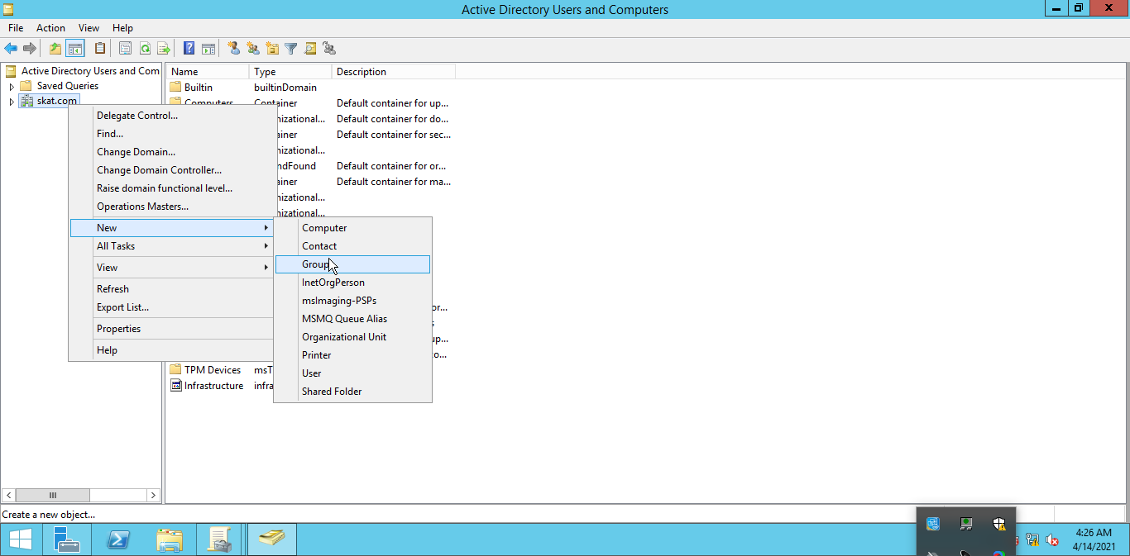

1. Now right-click on your domain (SKAT.COM) to add a new group.
2. Now a few more items of information to create a new group like Group Name, Group Scope, Group Type, etc. and then click the "Ok" Button.

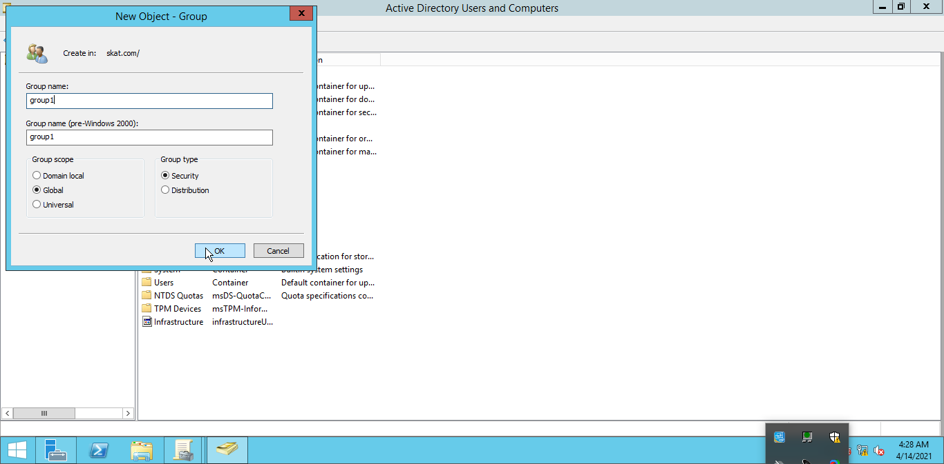

**Step 3: Create a 3 Organizational Unit**

1. Run [Server Manager] and click [Tools] - [Active Directory Users and Computers].



1. Click with right button [Organizational Unit] on left tree and select [New] - [Organizational Unit].

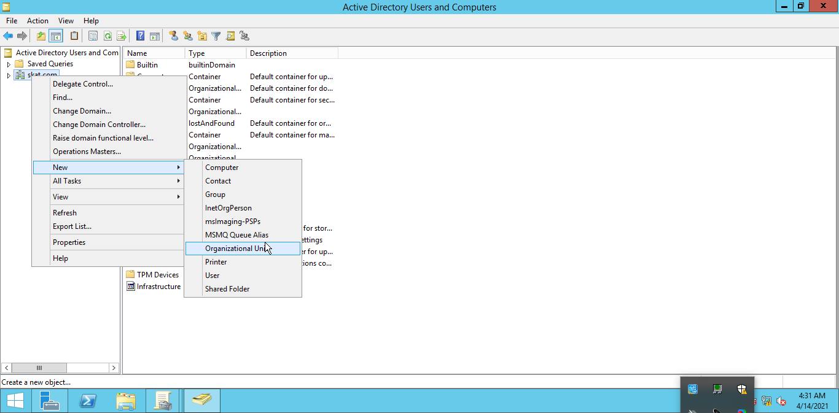

1. It will open “New Object-Organizational Unit console”, type OU name in name tab. Select an option “protect the container from accidental deletion”, it will use enhance security and prevent accidental deletion of OU. We’ll cover the steps to delete an OU by removing extra protection in future articles. Click on OK to close the window.

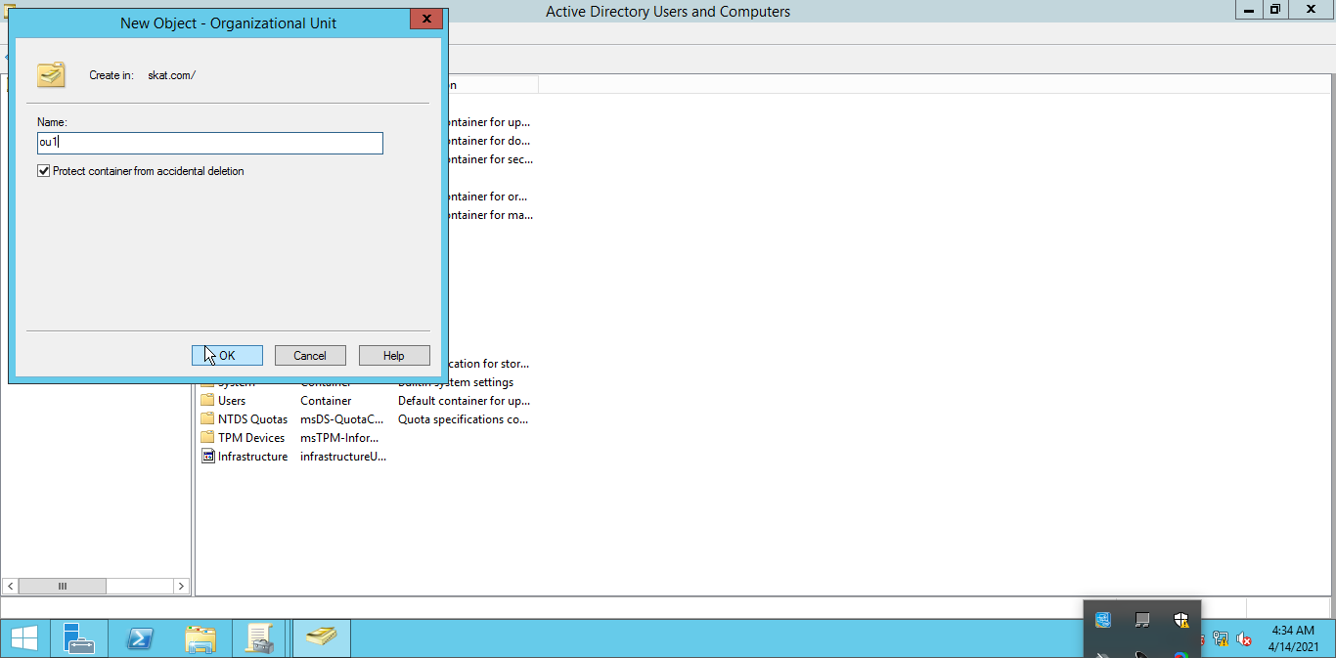

1. Here we can see that the Organizational Unit (OU1, OU2 & OU3) is created.

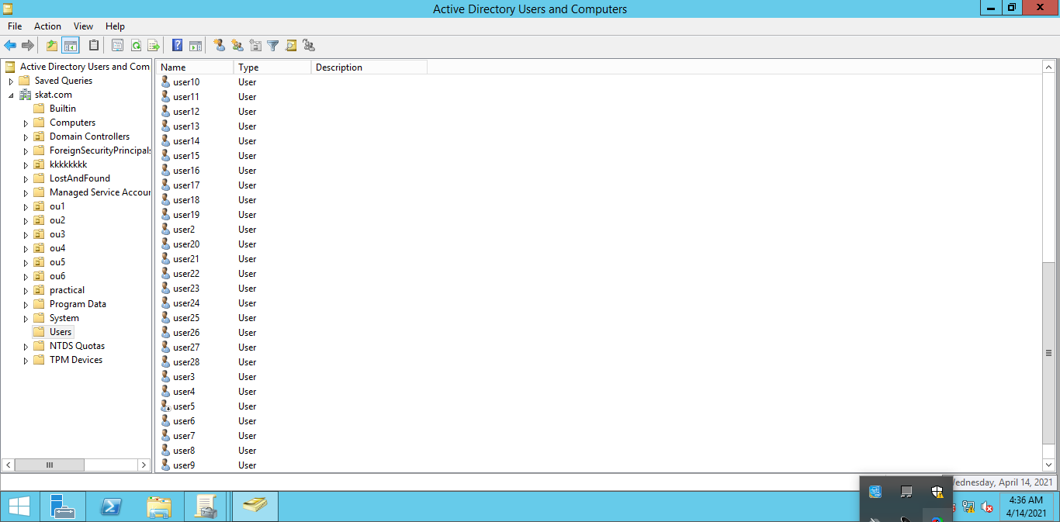

**Aim 3: Set 3 Group Policy Organizational to be applied overs 3 OUs**

On a computer that has the Group Policy Management feature installed, click the **Start**, and then click the **Group Policy Management** tile.

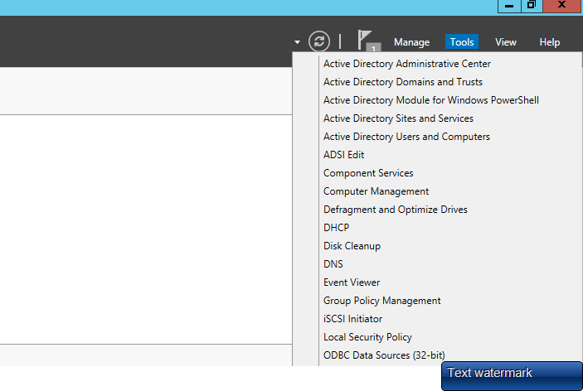

In the navigation pane, expand Forest: *SKAT.COM,* expand **Domains**, expand *SKAT.COM*, and then click **Group Policy Objects.**

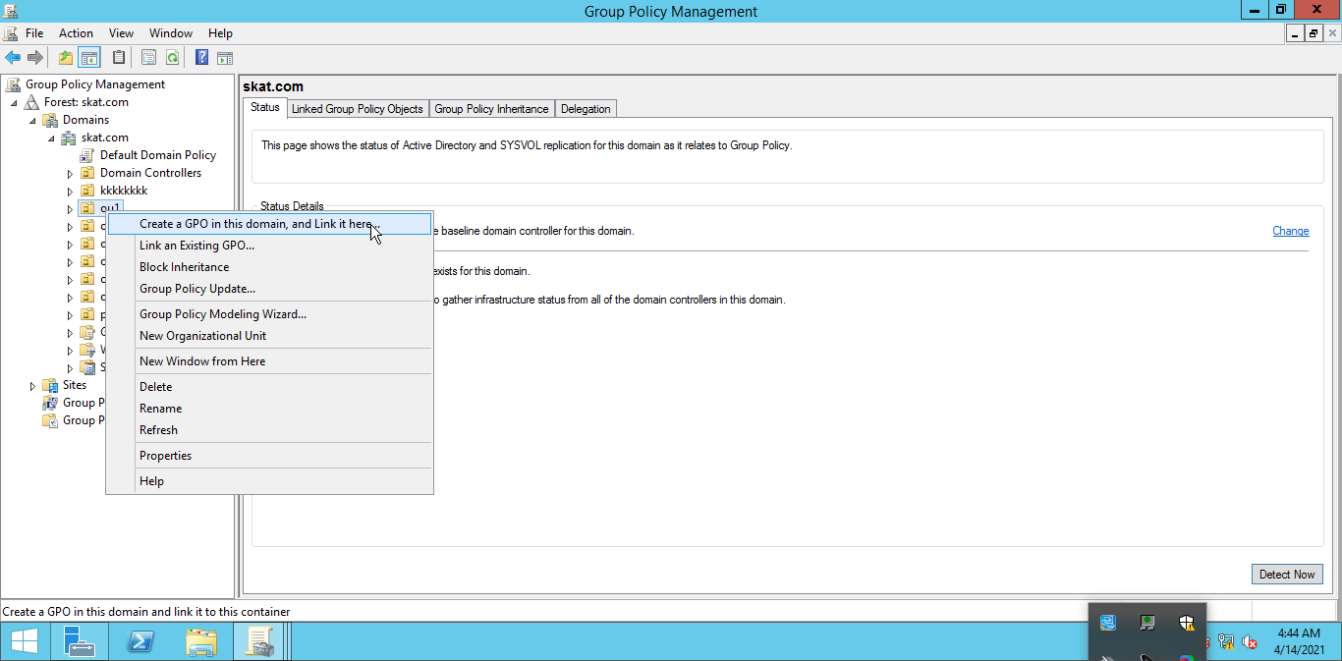

Click **Action**, and then click **New**

In the **Name** text box, type the name for your new GPO. Leave **Source Starter GPO** set to **(none), and then click OK.**

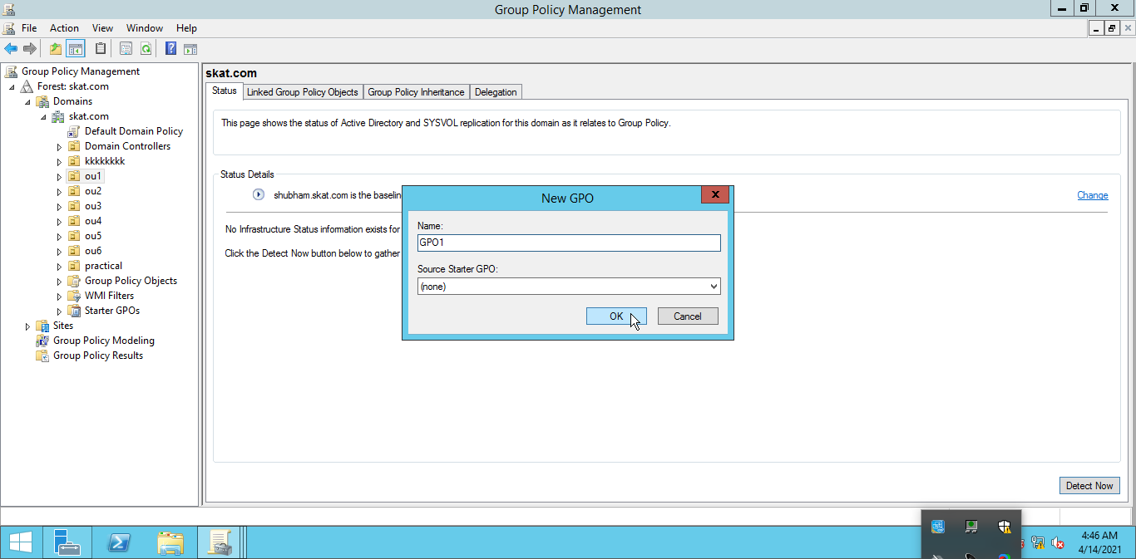

Next, **right-click** the **GPO object** and click **edit**:

At this point we have to enable policies for users: -

“Remove Add or Remove Progress”,” Remove Support Information”.

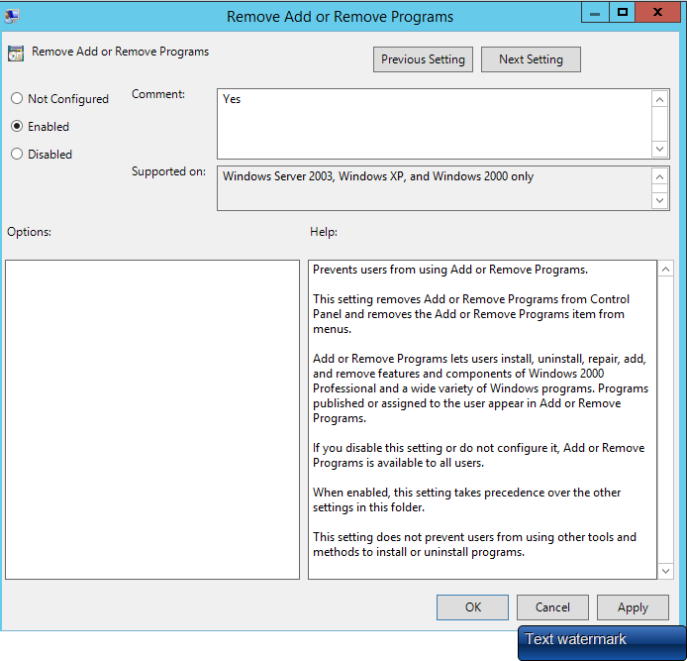

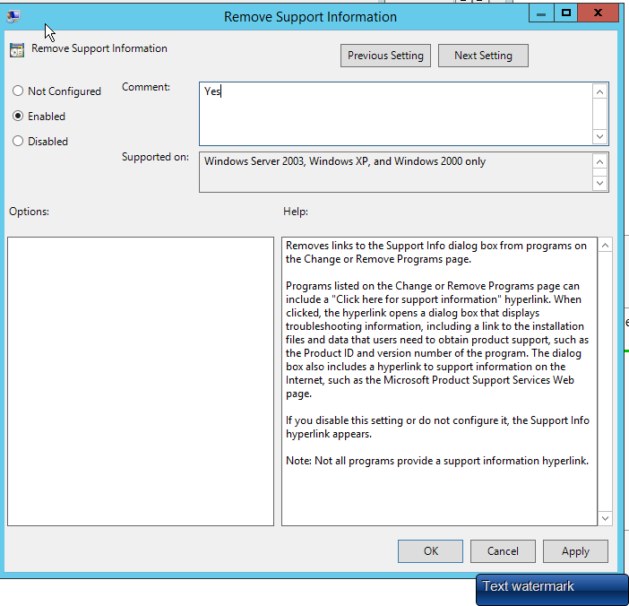

1. “Disable the Display Control Panel”, “Hide Settings Tabs”.

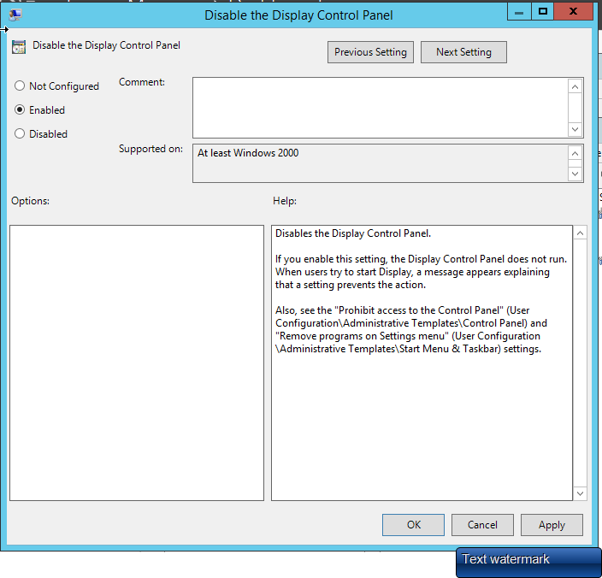

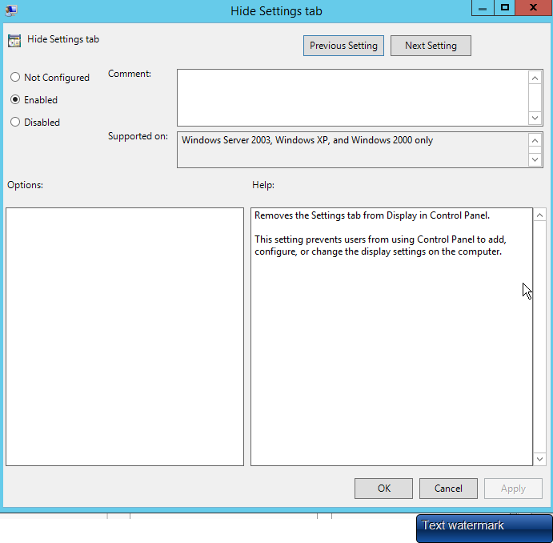

1. “Prevent Changing color scheme”, “Prevent changing theme”

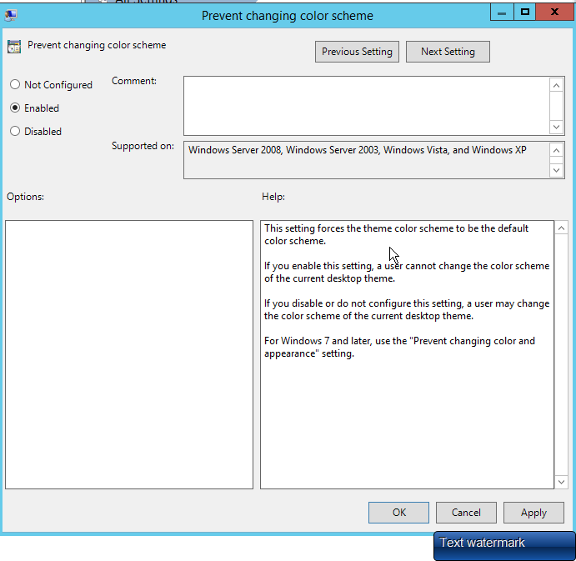

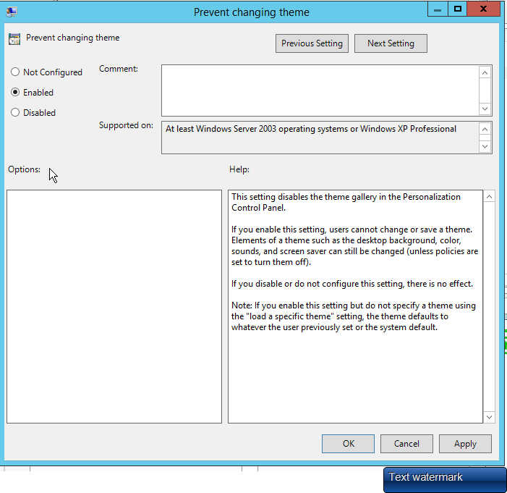

1. In order to confirm that this setting is working we need to test on one of the PCs that are affected by this policy.
2. Log on onto the PC – command prompt with administrative privileges (run as administrator) : gpupdate /force

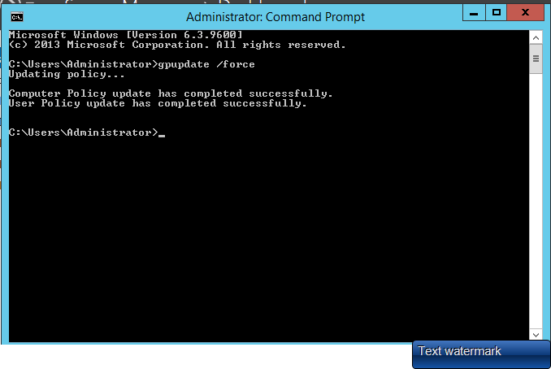

**CONCLUSION**

In this project, we created a domain controller. Its purpose is to respond to authentication requests and verifying users on computer networks. It is a hierarchical way of organizing users and computers on the same network. Then we configured the DNS and DHCP where the range of DHCP was up to 97 different IP addresses. We needed DHCP and DNS because we didn’t want to manually manage those settings for each PC on the network.

After that we created users and put them into groups. We learnt that groups can help us manage our accounts and applications very easily. When we create a group, we can gather similar users together and grant application access or special permissions to all members at once. For example, we can frequently share all applications with all 27 people in a group at once, with the help of GPO. GPOs are very useful to prevent users from accessing specific resources, run scripts and perform simple tasks such as forcing a particular homepage to open for every user in network. It enhances security.

**Thank You…**